Secant–Secant Theorem
# Source: AI Source: Provided by: [Data Path: Persons Table -> ID Column: 1, Name_En Column: Motasem Essam] -> From: [ChatGPT] on [7/25/2026]
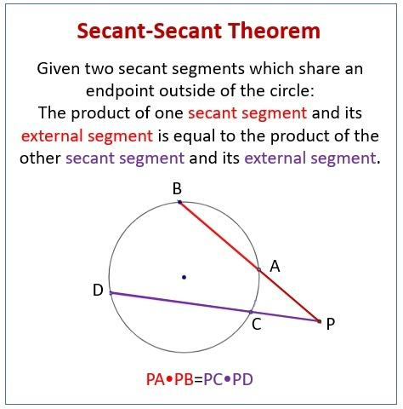
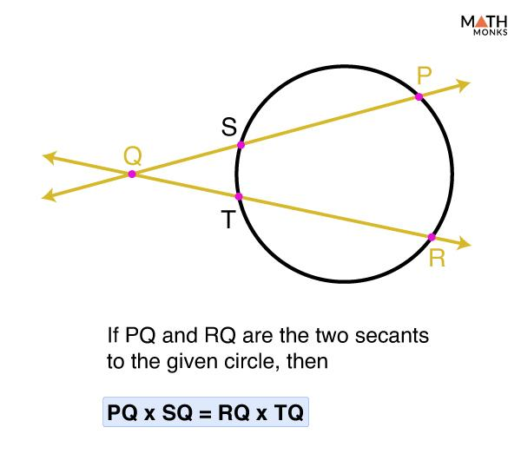
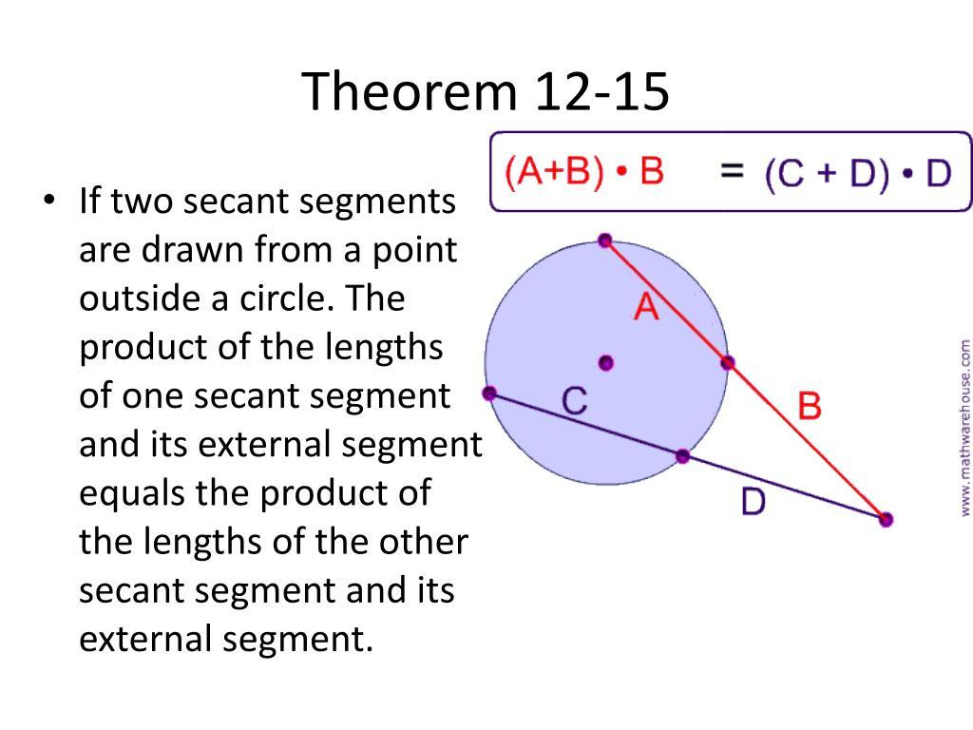
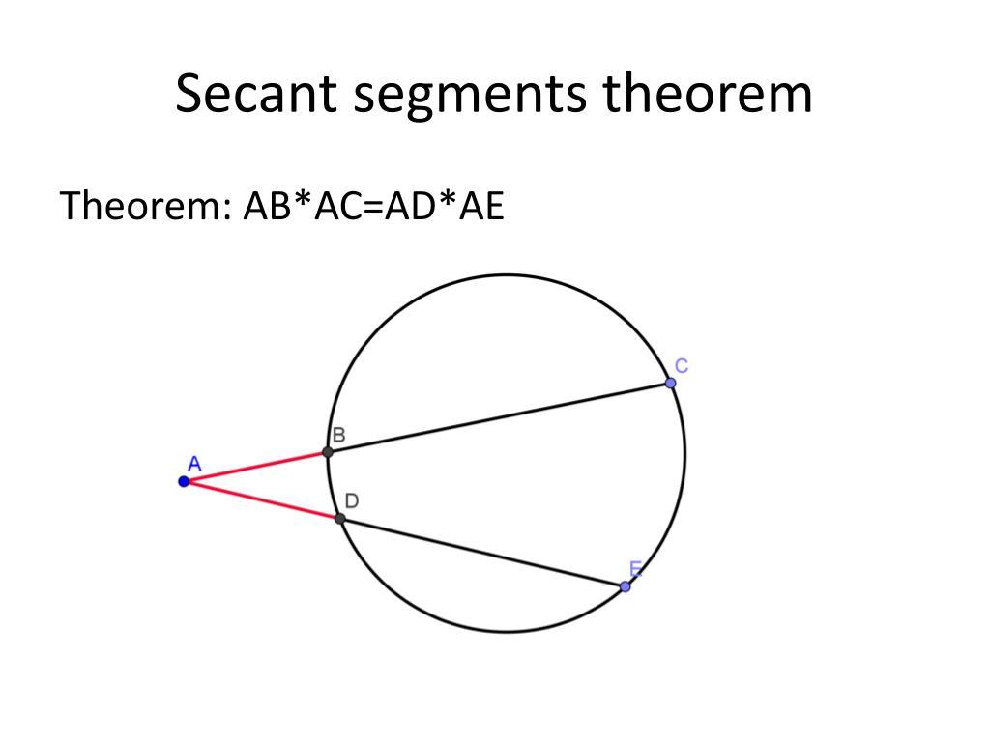

Definition
# Source: AI Source: Provided by: [Data Path: Persons Table -> ID Column: 1, Name_En Column: Motasem Essam] -> From: [ChatGPT] on [7/25/2026]
The Secant–Secant Theorem states that when two secants are drawn from the same external point to a circle, the product of the external segment and the entire secant segment is the same for both secants.
If two secants from an external point $P$intersect the circle at $A,B$and $C,D$, then:
$$\boxed{PA⋅PB=PC⋅PD}$$
where:
- $PA$and $PC$are the external secant segments.
- $PB$and $PD$are the entire secant segments.

Fundamental Concept
# Source: AI Source: Provided by: [Data Path: Persons Table -> ID Column: 1, Name_En Column: Motasem Essam] -> From: [ChatGPT] on [7/25/2026]
Suppose two secants originate from the same external point $P$.
The first secant intersects the circle at $A$and $B$:
$$P-A-B$$
The second secant intersects the circle at $C$and $D$:
$$P-C-D$$
Then:
$$\boxed{PA⋅PB=PC⋅PD}$$
This common value is the power of point $P$with respect to the circle.

Main Parts
# Source: AI Source: Provided by: [Data Path: Persons Table -> ID Column: 1, Name_En Column: Motasem Essam] -> From: [ChatGPT] on [7/25/2026]
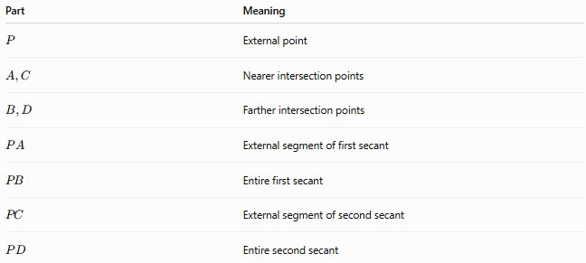
Part | Meaning
$$P$$ | External point
$$A,C$$ | Nearer intersection points
$$B,D$$ | Farther intersection points
$$PA$$ | External segment of first secant
$$PB$$ | Entire first secant
$$PC$$ | External segment of second secant
$$PD$$ | Entire second secant
The fundamental relationship is:
$$\boxed{PA⋅PB=PC⋅PD}$$

Theorem Statement
# Source: AI Source: Provided by: [Data Path: Persons Table -> ID Column: 1, Name_En Column: Motasem Essam] -> From: [ChatGPT] on [7/25/2026]
If two secants are drawn from the same external point to a circle, the product of the external segment and the entire secant segment is equal for both secants.
Therefore:
$$\boxed{\left(\text{External}\right)\left(\text{Whole}\right)=\left(\text{External}\right)\left(\text{Whole}\right)}$$
or:
$$\boxed{PA⋅PB=PC⋅PD}$$

Example 1 — Direct Application
# Source: AI Source: Provided by: [Data Path: Persons Table -> ID Column: 1, Name_En Column: Motasem Essam] -> From: [ChatGPT] on [7/25/2026]
Suppose:
$$PA=4, PB=18$$
and:
$$PC=6$$
Find $PD$.
Using the theorem:
$$PA⋅PB=PC⋅PD \\ 4\left(18\right)=6\left(PD\right) \\ 72=6PD$$
Therefore:
$$\boxed{PD=12}$$

Example 2 — Finding an External Segment
# Source: AI Source: Provided by: [Data Path: Persons Table -> ID Column: 1, Name_En Column: Motasem Essam] -> From: [ChatGPT] on [7/25/2026]
Suppose:
$$PA=5, PB=20, PD=25$$
Find $PC$.
$$PA⋅PB=PC⋅PD \\ 5\left(20\right)=PC\left(25\right) \\ 100=25PC$$
Therefore:
$$\boxed{PC=4}$$

Example 3 — Finding the Entire Secant
# Source: AI Source: Provided by: [Data Path: Persons Table -> ID Column: 1, Name_En Column: Motasem Essam] -> From: [ChatGPT] on [7/25/2026]
Suppose:
$$PA=8, PC=4, PD=24$$
Find $PB$.
$$8\left(PB\right)=4\left(24\right) \\ 8PB=96 \\ \boxed{PB=12}$$

External Segment and Internal Chord
# Source: AI Source: Provided by: [Data Path: Persons Table -> ID Column: 1, Name_En Column: Motasem Essam] -> From: [ChatGPT] on [7/25/2026]
The entire secant consists of:
$$\boxed{\text{Entire Secant}=\text{External Segment}+\text{Internal Chord}}$$
For the first secant:
$$\boxed{PB=PA+AB}$$
For the second:
$$\boxed{PD=PC+CD}$$
Therefore, the theorem can also be written as:
$$\boxed{PA\left(PA+AB\right)=PC\left(PC+CD\right)}$$
This form is useful when the chord portions inside the circle are given.

Relationship with Power of a Point
# Source: AI Source: Provided by: [Data Path: Persons Table -> ID Column: 1, Name_En Column: Motasem Essam] -> From: [ChatGPT] on [7/25/2026]
The Secant–Secant Theorem is one of the principal forms of the Power of a Point relationship.
For external point $P$:
$$\boxed{Pow⁡\left(P\right)=PA⋅PB}$$
Using the second secant:
$$\boxed{Pow⁡\left(P\right)=PC⋅PD}$$
Therefore:
$$\boxed{PA⋅PB=PC⋅PD}$$
So both secants produce exactly the same power.

Relationship with the Tangent–Secant Theorem
# Source: AI Source: Provided by: [Data Path: Persons Table -> ID Column: 1, Name_En Column: Motasem Essam] -> From: [ChatGPT] on [7/25/2026]
The two theorems have the same underlying principle.
Secant–Secant
$$\boxed{PA⋅PB=PC⋅PD}$$
Tangent–Secant
$$\boxed{PT^{2}=PA⋅PB}$$
A tangent can be viewed as a limiting case of a secant, which explains why the tangent segment appears twice:
$$PT⋅PT=PT^{2}$$
Thus, both formulas represent the Power of a Point.

Relationship with the Tangent Segments Theorem
# Source: AI Source: Provided by: [Data Path: Persons Table -> ID Column: 1, Name_En Column: Motasem Essam] -> From: [ChatGPT] on [7/25/2026]
If two tangents are drawn from the same external point $P$, with tangent points $T$and $U$:
$$PT=PU$$
Therefore:
$$PT^{2}=PU^{2}$$
This is consistent with the power relationship:
$$\boxed{Pow⁡\left(P\right)=PT^{2}=PU^{2}}$$
The three important external-point relationships are therefore:
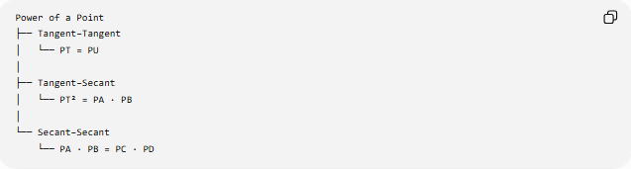
Power of a Point
├── Tangent–Tangent
│ └── PT = PU
│
├── Tangent–Secant
│ └── PT² = PA · PB
│
└── Secant–Secant
└── PA · PB = PC · PD

Proof of the Theorem
# Source: AI Source: Provided by: [Data Path: Persons Table -> ID Column: 1, Name_En Column: Motasem Essam] -> From: [ChatGPT] on [7/25/2026]
Consider two secants:
$$P-A-B$$
and:
$$P-C-D$$
The appropriate angles formed by the two secants and the circle lead to a pair of similar triangles.
From the similarity relationship:
$$\frac{PA}{PC}=\frac{PD}{PB}$$
Cross-multiplying:
$$PA⋅PB=PC⋅PD$$
Therefore:
$$\boxed{PA⋅PB=PC⋅PD}$$
This proves the Secant–Secant Theorem.

Geometric Interpretation
# Source: AI Source: Provided by: [Data Path: Persons Table -> ID Column: 1, Name_En Column: Motasem Essam] -> From: [ChatGPT] on [7/25/2026]
The theorem says that although the two secants can have completely different lengths and directions, they produce the same product:
$$PA⋅PB$$
and:
$$PC⋅PD$$
This common product depends only on the external point $P$and the circle, not on the particular secant chosen.
That common value is:
$$\boxed{Pow⁡\left(P\right)}$$

Coordinate Relationship
# Source: AI Source: Provided by: [Data Path: Persons Table -> ID Column: 1, Name_En Column: Motasem Essam] -> From: [ChatGPT] on [7/25/2026]
For a circle with center $O$, radius $r$, and external point $P$:
$$\boxed{Pow⁡\left(P\right)=PO^{2}-r^{2}}$$
Therefore:
$$\boxed{PA⋅PB=PC⋅PD=PO^{2}-r^{2}}$$
This gives three equivalent ways to calculate the power:
$$\boxed{Pow⁡\left(P\right)=PA⋅PB=PC⋅PD=PO^{2}-r^{2}}$$

Example Using the Center
# Source: AI Source: Provided by: [Data Path: Persons Table -> ID Column: 1, Name_En Column: Motasem Essam] -> From: [ChatGPT] on [7/25/2026]
Suppose:
$$PO=13$$
and:
$$r=5$$
Then:
$$Pow⁡\left(P\right)={13}^{2}-5^{2} \\ =169-25 \\ =144$$
Therefore, every secant through $P$satisfies:
$$\boxed{\text{External Segment}×\text{Entire Secant}=144}$$
For example:
$$PA=8, PB=18$$
gives:
$$8\left(18\right)=144$$
Another secant could have:
$$PC=12, PD=12$$
but that would correspond to a tangent limit rather than a distinct external secant, so for an actual secant the two intersection distances are distinct and satisfy the appropriate geometry.

Important Conditions
# Source: AI Source: Provided by: [Data Path: Persons Table -> ID Column: 1, Name_En Column: Motasem Essam] -> From: [ChatGPT] on [7/25/2026]
The standard external Secant–Secant Theorem requires:
- $P$is outside the circle.
- Both lines are secants.
- Both secants originate from the same point $P$.
- Each secant intersects the circle at two distinct points.
- The nearer intersection is used for the external segment.
- The farther intersection is used for the entire secant.
Thus:
$$P-A-B$$
and:
$$P-C-D$$

Special Case: Two Secants Have the Same External Segment
# Source: AI Source: Provided by: [Data Path: Persons Table -> ID Column: 1, Name_En Column: Motasem Essam] -> From: [ChatGPT] on [7/25/2026]
If:
$$PA=PC$$
then:
$$PA⋅PB=PC⋅PD$$
Since $PA=PC$:
$$PB=PD$$
Thus, equal external segments produce equal entire secant lengths.

Special Case: Secant Through the Center
# Source: AI Source: Provided by: [Data Path: Persons Table -> ID Column: 1, Name_En Column: Motasem Essam] -> From: [ChatGPT] on [7/25/2026]
If a secant passes through the center, the internal chord is a diameter.
If the radius is $r$:
$$AB=2r$$
and:
$$PB=PA+2r$$
Therefore:
$$\boxed{PA\left(PA+2r\right)}$$
is the power of the external point along that secant.

Comparison with Related Theorems
# Source: AI Source: Provided by: [Data Path: Persons Table -> ID Column: 1, Name_En Column: Motasem Essam] -> From: [ChatGPT] on [7/25/2026]
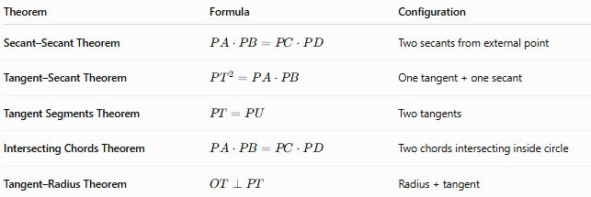
Theorem | Formula | Configuration
Secant–Secant Theorem | $$PA⋅PB=PC⋅PD$$ | Two secants from external point
Tangent–Secant Theorem | $$PT^{2}=PA⋅PB$$ | One tangent + one secant
Tangent Segments Theorem | $$PT=PU$$ | Two tangents
Intersecting Chords Theorem | $$PA⋅PB=PC⋅PD$$ | Two chords intersecting inside circle
Tangent–Radius Theorem | $$OT⊥PT$$ | Radius + tangent

External Secants vs. Intersecting Chords
# Source: AI Source: Provided by: [Data Path: Persons Table -> ID Column: 1, Name_En Column: Motasem Essam] -> From: [ChatGPT] on [7/25/2026]
These two formulas look identical but describe different configurations.
Secants from an External Point
The intersection point is outside the circle:
$$\boxed{PA⋅PB=PC⋅PD}$$
The factors are:
$$\text{external}×\text{whole}$$
Chords Intersecting Inside
If chords intersect at $P$inside the circle:
$$\boxed{PA⋅PB=PC⋅PD}$$
The factors are the two segments of each chord.
So the formula is the same, but the geometric configuration and interpretation of the segments are different.

Classification
# Source: AI Source: Provided by: [Data Path: Persons Table -> ID Column: 1, Name_En Column: Motasem Essam] -> From: [ChatGPT] on [7/25/2026]
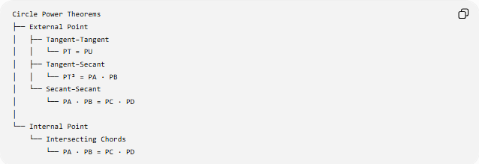
Circle Power Theorems
├── External Point
│ ├── Tangent–Tangent
│ │ └── PT = PU
│ ├── Tangent–Secant
│ │ └── PT² = PA · PB
│ └── Secant–Secant
│ └── PA · PB = PC · PD
│
└── Internal Point
└── Intersecting Chords
└── PA · PB = PC · PD

Key Formulas
# Source: AI Source: Provided by: [Data Path: Persons Table -> ID Column: 1, Name_En Column: Motasem Essam] -> From: [ChatGPT] on [7/25/2026]
Main theorem
$$\boxed{PA⋅PB=PC⋅PD}$$
Power of an external point
$$\boxed{Pow⁡\left(P\right)=PA⋅PB}$$
Using the second secant
$$\boxed{Pow⁡\left(P\right)=PC⋅PD}$$
Using the center and radius
$$\boxed{Pow⁡\left(P\right)=PO^{2}-r^{2}}$$
Therefore:
$$\boxed{PA⋅PB=PC⋅PD=PO^{2}-r^{2}}$$
Entire secant
$$\boxed{PB=PA+AB} \\ \boxed{PD=PC+CD}$$

Key Points
# Source: AI Source: Provided by: [Data Path: Persons Table -> ID Column: 1, Name_En Column: Motasem Essam] -> From: [ChatGPT] on [7/25/2026]
- Two secants originate from the same external point.
- Each secant has an external segment and an entire segment.
- The products of these corresponding segments are equal:
$$\boxed{PA⋅PB=PC⋅PD}$$
- The common product is the power of the external point.
- The theorem is closely related to the Tangent–Secant Theorem.
- If a tangent replaces one secant, the formula becomes:
$$\boxed{PT^{2}=PA⋅PB}$$
- The entire secant equals external segment plus the internal chord:
$$\boxed{PB=PA+AB}$$

Conclusion
# Source: AI Source: Provided by: [Data Path: Persons Table -> ID Column: 1, Name_En Column: Motasem Essam] -> From: [ChatGPT] on [7/25/2026]
The Secant–Secant Theorem establishes that two secants drawn from the same external point to a circle have equal external-whole products:
$$\boxed{{\text{External}}_{1}×{\text{Whole}}_{1}={\text{External}}_{2}×{\text{Whole}}_{2}}$$
or:
$$\boxed{PA⋅PB=PC⋅PD}$$
It is one of the central Power of a Point theorems, alongside the Tangent–Secant Theorem, Tangent Segments Theorem, and Intersecting Chords Theorem.

